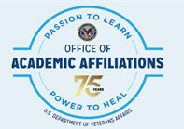
  - VA Residency Training Programs
This is a comprehensive list of all VA residency programs by specialty including accredited, candidate* and developing**. Please apply through RF-PTCAS.

